If a cook can make 14 hamburgers per hour, how many hamburgers can he make in 8 hours?

86

92

72

104

112

Which of the following is the smallest value?

11

0.675

1.23

0.42

1.011

An automobile dealership sells 200 cars in the month of June. If it sells 35% more cars in the next month, how many cars does it sell in July?

235

260

270

280

290

Which of the following boxes should replace the question mark (?) to complete the pattern?

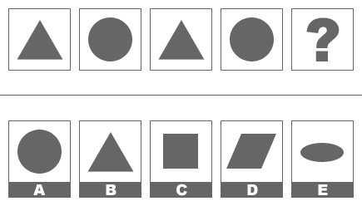

A

B

C

D

E

Which of the following boxes should replace the question mark (?) to complete the pattern?

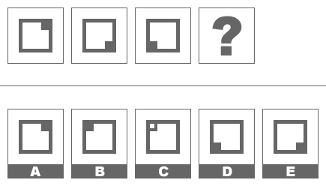

A

B

C

D

E

Which of the following boxes should replace the question mark (?) to complete the pattern?

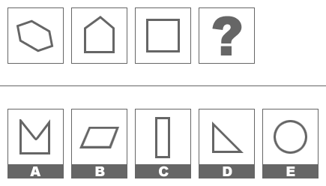

A

B

C

D

E

Which of the following boxes should replace the question mark (?) to complete the pattern?

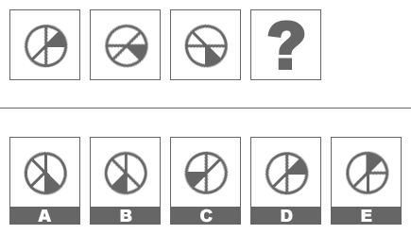

A

B

C

D

E

CHEESE is to EAT as ...

WOUND is to HURT

CLIMB is to TREE

CLEAN is to NAPKIN

SHIRT is to WEAR

LETTUCE is to LEAF

PAPER is to THIN as...

FLEA is to TINY

BINDER is to ORGANIZE

PRINTER is to COPY

RABBIT is to WISHFUL

SPOON is to SULKY

ILLEGIBLE is to READ as ...

INCORRIGIBLE is to BEHOLD

INCOMPREHENSIBLE is to UNDERSTAND

INDEFENSIBLE is to ATTEMPT

INDEFATIGABLE is to ROUSE

INDELIBLE is to DEFEND

Choose the word or words that, when inserted in the sentence to replace the blank or blanks, best fits the meaning of the sentence.

The duckling tried to ________ its mother by following her every step.

Rival

Confront

Personify

Immerse

Emulate

Choose the word or words that, when inserted in the sentence to replace the blank or blanks, best fits the meaning of the sentence.

The company's management ________ its resources extremely carefully, in order to ensure every division maximized its profitability.

demonstrated

elucidated

constructed

allocated

hedged

Choose the word or words that, when inserted in the sentence to replace the blank or blanks, best fits the meaning of the sentence.

Because the prosecution witness' story was not _________ by other sources, the jury felt ________ to find the defendant not guilty.

contaminated .. relieved

contradicted .. constrained

criticized .. elated

endorsed .. reluctant

substantiated .. compelled

Choose the word or words that, when inserted in the sentence to replace the blank or blanks, best fits the meaning of the sentence.

Apparently _________ by convention or modesty, the vacationer decided to sunbathe in the nude on the crowded beach.

unmasked

unconstrained

discomfited

disguised

compelled

Which of the following does not belong?

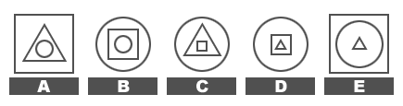

A

B

C

D

E

Which of the following does not belong?

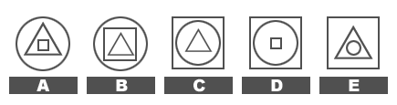

A

B

C

D

E

Which of the following does not belong?

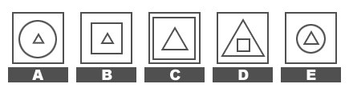

A

B

C

D

E

Which of the following does not belong?

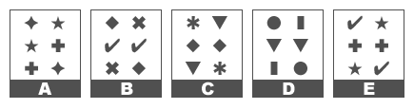

A

B

C

D

E

In a class of forty students, one fifth of the students also play on the school’s football team. If four more students from the class join the football team, what percentage of students in the class will be on the football team?

25%

30%

33%

35%

40%

24 is 60% of what number?

56

48

36

32

40

What would be the next group of letters in the following series?  
  
akje ... ajif ... aihg ... ahgh ?

agff

agfi

aggi

aifh

aifi

Assume the first two statements are true. Is the final statement: 1) True, 2) False, or 3) Uncertain based on the information provided?

Susan is taller than Lisa.  
Lisa is shorter than Jean.  
Jean is taller than Susan.

True

False

Uncertain

Assume the first two statements are true. Is the final statement: 1) True, 2) False, or 3) Uncertain based on the information provided?

Debbie is a cooking instructor.  
All cooking instructors went to cooking school.  
Debbie went to cooking school.

True

False

Uncertain

Assume the first two statements are true. Is the final statement: 1) True, 2) False, or 3) Uncertain based on the information provided?

Adam is a better golfer than Walter.  
Linda is a better golfer than Walter.  
Adam is a better golfer than Linda.

True

False

Uncertain

How many of the five items in the left hand column are exactly the same as the corresponding entry in the right hand column?

|  |  |
| --- | --- |
| Williams Manufacturing | Williams Manufacturing |
| Donaldson Realty | Donaldson Realty |
| Bullock Engineering | Bullock Engineering |
| Granger Industries | Grainger Industries |
| Richardson Architecture | Richardson Architecture |

1

2

3

4

5

How many of the five items in the left hand column are exactly the same as the corresponding entry in the right hand column?

|  |  |
| --- | --- |
| Middleton Training Inc. | Middletown Training Inc. |
| Laurelmont Corp. | Laurelmont Co. |
| Harrell Automotive | Harrell Automotive |
| Two Ferns Realty | Two Ferns Realty |
| Simpson Hardware | Stimpson Hardware |

1

2

3

4

5

How many of the five items in the left hand column are exactly the same as the corresponding entry in the right hand column?

|  |  |
| --- | --- |
| 12 Valley Dr. # 4. | 12 Valley Dr. |
| 56 Deerbrook Ln. | 56 Deerbrook Ln. |
| 401 Redhawk Ave. | 401 Redhawk Ave. |
| 124 Williams Blvd. | 124 Williams Blvd. |
| 3250 Mullin Dr. | 3250 Mullin Dr. |

1

2

3

4

5

Which of the following boxes should replace the question mark (?) to complete the pattern?

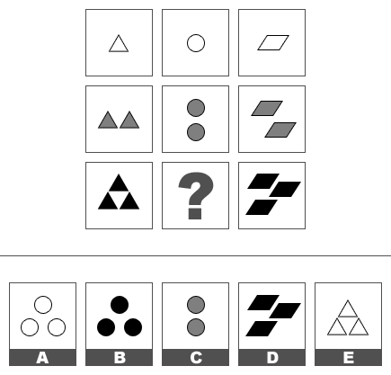

A

B

C

D

E

Which of the following boxes should replace the question mark (?) to complete the pattern?

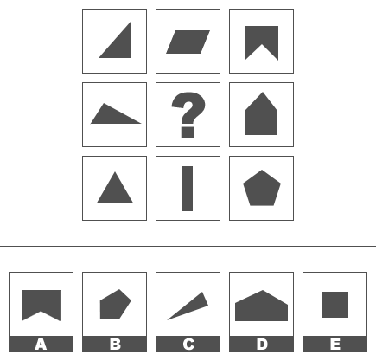

A

B

C

D

E

Which of the following boxes should replace the question mark (?) to complete the pattern?

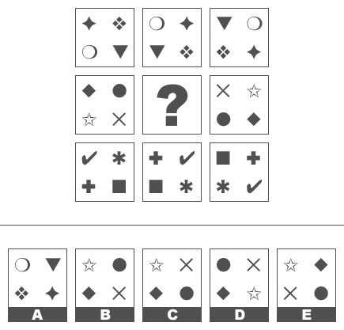

A

B

C

D

E

What would be the next number in the following series?   
  
2 ... 4 ... 7 ... 11 ... 16 ...?

21

22

23

25

27

A restaurant uses 1.5 potatoes in order to make each order of French fries. If it serves 300 orders of French fries per day, how many potatoes will it need each day?

200

240

360

420

450

A company has two production facilities that have production capacities of 100 units per day, and 60 units per day, respectively. How long will it take for both locations to produce a combined total of 2,000 units?

9.5 days

12.5 days

14 days

15.5 days

20 days

Choose the word or words that, when inserted in the sentence to replace the blank or blanks, best fits the meaning of the sentence.

Among geologists there are a variety of opinions as to how the Grand Canyon was formed, and until further research _______ the issue it is unlikely that we will move toward a _______ theory of its origins.

explores . . convincing

clarifies . . unified

investigates . . contemptuous

corroborates . . definitive

elucidates . . unique

Choose the word or words that, when inserted in the sentence to replace the blank or blanks, best fits the meaning of the sentence.

Hunters argue that they provide a valuable service by trimming the numbers of deer, __________ in this country for some time, so that their growing numbers don't upset the balance of local ecosystems.

recalcitrant

reclusive

ubiquitous

parochial

licentious

The table below shows the number of homeruns hit by Mickey Mantle and Roger Maris when they played together on the Yankees between 1960 and 1964. Expressed as a percentage, how many more home runs did Maris hit in 1962?

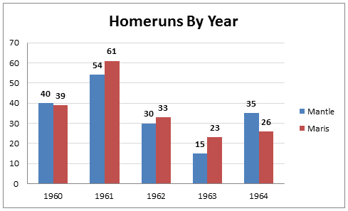

3%

9%

10%

17%

33%

A group of five numbers has an average (arithmetic mean) of 20. The first four numbers are 12, 16, 17, and 23. What is the fifth number?

24

27

29

30

32

An investor purchases shares in a company for $10/share. The shares appreciate 20% in the first year and 25% the next. What is the price of the stock after two years?

$14.50/share

$15.00/share

$15.50/share

$16.50/share

$17.00/share

A restaurant buys 1500 eggs per week, at $1.50 per dozen. If the cost per dozen eggs rises to $1.80, how much more will the restaurant have to pay for eggs per week?

$23.25

$35

$32.75

$37.50

$28.50

Choose the word that is most nearly OPPOSITE to the word in capital letters.

OSTENTATIOUS

omnipotent

refined

modest

undignified

gorgeous

Choose the word that is most nearly OPPOSITE to the word in capital letters.

COMPLY

approve

restate

resent

rescind

resist

FALLIBLE is to MISTAKE as ...

GULLIBLE is to MISLEAD

RATIONAL is to REASON

LEGIBLE is to WRITING

CREDIBLE is to DELAY

FUNGIBLE is to DISTRACT

CULPABLE is to BLAME as ...

EDIBLE is to TASTE

MALLEABLE is to CENSURE

MENIAL is to DISGUST

PENAL is to INCARCERATION

LAUDABLE is to PRAISE

Choose the word or words that, when inserted in the sentence to replace the blank or blanks, best fits the meaning of the sentence.

Aware of the political _______ of making a magnanimous gesture of support, the politician extended her best wishes to her opponent when he fell ill, despite the fact that she had nothing but _______ for him.

favor ... disdain

advantages ... respect

utility ... contempt

convenience ... sadness

benefits ... regret

A basketball team knows that it can sell all 1,000 seats in its arena for a price of $15, but determines that if it sells tickets for $20 then it will only sell 90% of the seats. By what percentage will the team increase its revenue if it decides to sell tickets for the higher price?

10%

12%

15%

18%

20%

A manufacturing company has two assembly lines, one with old equipment and one with new. The old assembly line generates products at a rate of 48 per hour, the new one at 60 per hour. If both assembly lines are operating at the same time, how long will it take them to create a total of 180 products?

1 hour and 20 minutes

1 hour and 24 minutes

1 hour and 30 minutes

1 hour and 36 minutes

1 hour and 40 minutes

The average (arithmetic mean) of 4 numbers is greater than 8 but less than 14. Which of the following could NOT be the sum of these four numbers?

44

53

38

31

48

If you flip a coin the chances it will come up heads are 50%. What are the chances that you can flip a coin three times and have it come up heads all three times?

11.1%

12.5%

14.3%

16.7%

20.0%

A restaurant sold 250 drinks in a night. Some of the drinks were sold for $2 each, and the rest for $5 each. If the total sales of drinks for the night was $830, how many $2 drinks were sold?

110

140

145

150

155

Kelly, Lisa, Mark, and Ned are friends. One is a painter, another a doctor, another a lawyer, and another a salesperson. Each has a hobby: their hobbies are tennis, jogging, poker, and gardening.   
  
1) Lisa is the lawyer.   
2) Mark is the doctor and his hobby is not gardening.   
3) The painter's hobby is jogging.   
4) Kelly's hobby is tennis.   
  
Even if we did not know that Kelly's hobby is tennis, which of the following statements could we deduce to be true?   
  
1 Kelly is either the painter or the salesperson   
2 Nancy's hobby is gardening   
3 Mark's hobby is either poker or tennis

1 only

2 only

3 only

1 and 2

1 and 3